Stakeholder Engagement Models / Tools for Discussion:

Levels of Engagement: Current and Future
Model 1: Arnstein’s Ladder of Engagement –
Questions to consider: Related to the Index project: At present, where do you see yourself and your constituency group on this ladder? Ideally, where do you think it appropriate for you and for your constituency to be? What strategies or activities in 2016 would help accomplish this?
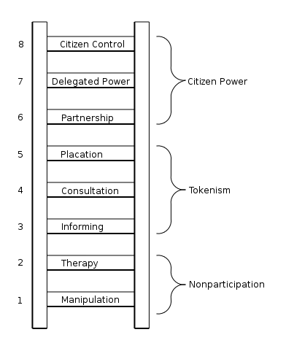
Reference: Arnstein, Sherry R. "A Ladder of Citizen Participation," JAIP, Vol. 35, No. 4, July 1969, pp. 216-224. http://lithgow-schmidt.dk/sherry-arnstein/ladder-of-citizen-participation.html
Bottom: Manipulation (1) and Therapy (2). These two rungs describe levels of "non-participation" that have been contrived by some to substitute for genuine participation. Their real objective is not to enable people to participate in planning or conducting programs, but to enable those in charge to "educate" or "cure" the participants.
Middle Rungs: Informing (3) and Consultation (4). These progress to levels of "tokenism" that allow stakeholders to hear and to have a voice: When they are proffered by management/those in power as the total extent of participation, stakeholders may indeed hear and be heard. But under these conditions they lack the power to insure that their views will be heeded. When participation is restricted to these levels, there is no follow-through, no "muscle," hence no assurance of changing the status quo or influencing the outcome. Placation (5) is simply a higher level tokenism because the ground rules allow stakeholders to advise, but retain for the power-holders the continued right to decide.
Further up the ladder are more active levels of stakeholder participation with increasing degrees of decision-making clout. Stakeholders can enter into a Partnership (6) that enables them to negotiate and engage in working through trade-offs with those in charge. At the topmost rungs, Delegated Power (7) and Citizen Control (8), stakeholders obtain the majority of decision-making seats, or full managerial power.
Levels of Engagement: Model 2: IFC Stakeholder Engagement Handbook
Some may relate to this model more. If so: At present, where do you see yourself and your constituency group on this spectrum? Ideally, where do you think it appropriate for you and for your constituency to be? What strategies or activities would help accomplish this in 2016?
Source: Reference: International Finance Corporation. World Bank Group. Stakeholder Engagement: A Good Practice Handbook for Companies Doing Business in Emerging Markets. Washington, DC.2007. URL: http://www.ifc.org/wps/wcm/connect/938f1a0048855805beacfe6a6515bb18/IFC_StakeholderEngagement.pdf?MOD=AJPERES

Mapping Stakeholders based on Expertise, Willingness, and Need to Engage:
BSR has developed a list of criteria to help organizations analyze stakeholders in order to guide thinking about the level with which different stakeholder groups need to / want to / should be engaged at different stages of an effort:

- Contribution: The amount of information, counsel, or expertise that could be helpful to the project.
- Legitimacy / Interest: How legitimate is the stakeholder’s claim for engagement? How much are they or issues they care deeply about affected by the effort? How critical is it for them that the effort is done right?
- Willingness to engage: How willing is the stakeholder to engage?
- Influence: How much influence does the stakeholder have? (what type? on whom?)
- Necessity/Criticality of involvement: Is this someone who could significantly advance the project and/ or, if not included, derail or delegitimize the process and effort?

Questions to Consider: By the fact that you are a part of the workgroup, your constituency is deemed very important to involve in this effort. That being said, groups each bring different levels of expertise, interest, willingness, and need for engagement to the table. Populate the chart below with short descriptions related to your constituency. Assign values (low, medium, or high) for each criteria, as it relates to your stakeholder group in the year ahead.
 | Expertise |  | Willingness | Value
Stakeholder Group | Contributions | Legitimacy / Interest | Willingness to Engage | Influence | Criticality of Involvement
Reference: BSR. Back to Basics: How to Make Stakeholder Engagement Meaningful for Your Company. January 2012. http://www.bsr.org/reports/BSR_Five-Step_Guide_to_Stakeholder_Engagement.pdf .

